Character astrology signs
After reading brief descriptions of the astrology or sun signs, figure out which signs you think three of the main characters from your book were born under. Write an explanation of why you think they fit the sign, drawing on their actions, attitudes, and thoughts from the book.

Bruno = Aries (born April 15)
Bruno (from the book Boy in the Striped Pajamas) is an Aries. Aries are born in April. Bruno has similar actions of an Aries Zodiac sign because they are known to be generous with toys. In the book, Boy in the Striped Pajamas, Bruno is a child who does share frequently with Shmuel (though he does not understand how desperately Shmuel needs the items he shares). Bruno frequently brings Shmuel food when he visits him at the fence. More often than not, Bruno does snack on them along the way, but always is generous enough to share what he does have with Shmuel. Aries are also adventurous, as we see with Bruno on many occasions when he sneaks away from the house to visit Shmuel at the fence.
Aries, in general, are people who like friends who are special in some particular way and who will regard Aries as his best friend. This shows Bruno’s attitude to Shmuel as he is his best friend. We know this by the amount of times Bruno visits Shmuel at the fence, and how he worries when he did not see him for days (while Shmuel was searching for his missing father). At the end of the novel, we learn that Bruno does not miss his three other friends from home; Karl, Daniel and Martin. In fact, Bruno also grabs Shmuel’s hand while they are in the gas chamber and tell him that he is “his best friend for life” (p.213).
An Aries life is an open book; therefore their thoughts are always made known. The moment, Bruno and his family move to Out-With Bruno’s father asks his opinion of the place. Bruno admits he is unhappy at his new life and asks his father what he did wrong to upset the Fury.

Create a childhood for a character
If your main character is an adult, try to figure out what he or she would have been like as a child. Write the story of his or her childhood in such a way that shows why he or she is the way he or she is in the novel.

Bruno’s family was not always the rich five-story house with a shiny banister type. In fact, when Bruno was first born, the family lived in a modest one-floor house. Gretel was the first to be upset at the new baby named Bruno that came home. Her parents had promised that if the baby were a girl, she could have a bunk bed in her room and share it with her sister.
Needless to say when Mother and Father showed Gretel the tiny Bruno, she cried in disappointment at not receiving bunk beds. Thankfully, neither Bruno nor Gretel remember this time of their past. How the family of four came to live in the stunning house in Berlin happened almost overnight. Bruno’s father had been always a part of the German military. One night, while attending a benefit supper for the Nazi party, Bruno’s father met a man many referred to as the Fueher. It happened very casually as Father was walking over to the punch bowl to obtain a drink for himself and Mother. There was another woman there pouring herself a drink. She kindly looked into Father’s eyes and smiled. She had beautiful blond hair that curled just over her eyebrows. Her eyes were a light azure in color. They caught a glance of each other and the picturesque woman helped Father pour two glasses of punch. Father introduced himself and as he did, The Fueher walked over to join them and introduced himself as well as the woman. The Fueher did not need any introduction whatsoever as everyone in the entire room knew who he was. Finally, as he was walking away from the table, The Fueher proudly announced to Eva, as he pulled her away, that he had big plans for Father.
Not long after that, The Fueher contacted Father and told him that he wanted him to move to Berlin to help right Germany’s wrongs. Father hung on every word The Fueher said and gladly moved his family of four to Berlin to aid in fixing the wrongs that Jews had done to Germany.

College application
Create the application that a character you have just read about could write and submit to a college. Use all the information you know about the character and infer and create the rest of it. On the application include:
Name, Academic Rank in Class, High School Courses Taken and
Grades, Extracurricular Activities and Personal Activities, and Work Experience.
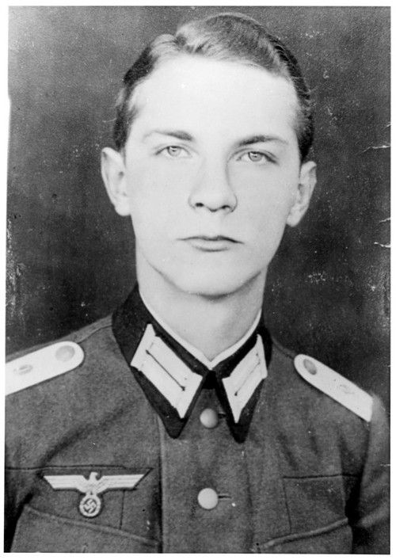

Name: Bruno
Academic Rank in Class: Honor Roll and Principal’s List
High School Courses Taken: History, Geography and Drama
Grades: History - 97%, Geography – 96%, Drama – 98%
Extracurricular Activities: Berlin Drama Production
Personal Activities: Outdoors Club
Work Experience: Military Camp Leader
Explanation:
Academic Rank – Bruno would have received fantastic grades in high school. The reasons why are because he had a private tutor names Herr Liszt, and Bruno’s parents (especially his father) are super strict and expect marks no less than the best.
High School Courses Taken – Bruno would have taken History and Geography because it was a course that Herr Liszt insisted Bruno and his sister Gretel take. The reason they had to do those courses is because they had to learn all the wrongs that Germany had received from the Jews. Bruno would have also taken Drama if he had the choice because it is a subject that he truly enjoys. When he was growing up his Grandmother worked in a play company. When there were special occasions, Grandmother would dress up Gretel and Bruno and have them act out a play.
Grades – Bruno’s grades would be very high in subjects he is interested in (for example Drama). In history and geography, Bruno’s father and Herr Liszt would push Bruno to do well. They would except no less. In other subjects, Bruno might not get the best marks, but he would need to pass.
Extra curricular Activities: Bruno would be part of the Berlin Drama Production. As this is his favorite activity and something that he had to give up for a short period of time when he was a kid. I choose Berlin has Bruno would have eventually moved back with his family to their five story home.
Personal Activities: Bruno loved exploring outdoors and indoors. He liked looking in and hiding in every spot in his five-story house. Bruno also enjoyed exploring around Out-With and in doing so he met a young by named Shmuel.
Work Experience: It is clear that if Bruno had made it to adulthood, that he would have been in the military in one-way or another. His father was in the military and a high-ranking officer, so by definition Bruno would have had a career in it as well.

Talk show invitation
Select a character, think about his or her involvements and experiences, then figure out which talk show would most want your character on as a guest. What would they want the character to talk about? Who else would they invite on the show to address the issues the character is involved in? Write up the correspondence between the talk show host and the character in which the host explains what the character should focus on while on the show. After the show, have them exchange one more letter mentioning how they felt about what happened.

Bruno would appear on the Oprah Winfrey Talk Show because she discusses real life examples of personal dilemmas and famous people in the media. Oprah would want to talk about Bruno’s time at Out-With, what he saw and how it made him feel. She would also invite the following characters – Plavel, Father, Shmuel and Kotler to see what happened to them after the book ends. For example; where did Lt. Kotler go after Father had him sent away. Did Lt. Kotler figure out where his father went. Did he ever get to meet back with up with Mother or did his affair end when he was sent away? Why did Kotler seem so shocked to see a child (Bruno) at first at Out-With?
Oprah: Welcome to the show Bruno.
Bruno: Thank you for having me Oprah.
Oprah: Bruno, how old are you now?
Bruno: I am currently 20 years old.
Oprah: Bruno, why did you not tell your parents about Shmuel when you first met him?
Bruno: I had this bad feeling that they would be mad at me. Especially since they told me to not venture off the property

Movie recommendations
From all the movies you’ve seen in the last couple of years, pick five you would recommend that your character see. Give a brief summary of each movie and explain why you think the character should see it.

Bruno should watch, Schindler’s list so that he understands what some people did in order to save those who were Jewish before they ended up at Out-With. Schindler is a businessman who hired only Jewish people to run his pots and pans factory. Once the factory closed, he opened a second factory (an ammunitions factory) in order to save all his workers. The factory never produced any working ammunitions.
Bruno should also watch Inside Out so that he understands what a childhood is really supposed to be like. In the movie, the main character Riley experiences a move (just like Bruno) and learns to deal with it in a positive way. By reviewing old memories, Riley learns that her family made the best decision from her, as Bruno’s parents eventually make for him when they decide to move back home.
Etc…

Word collage
Write the title of the book in the center of a sheet of paper. Then look through magazines for words, phrases, and sentences that illustrate or tell something about your book. As you look, think in terms of the theme, setting, plot line, as well as characters. Work to get fifty such words, phrases, or sentences so the whole sheet of paper will be covered. The visual impact of the collage should tell a potential reader a lot about the book.

See image – “Wordle”
I chose the word hopeless case because it is a word that is repeated often in reference to Gretel, Bruno’s older sister.
I also chose the word armband because it is something that is different from Bruno to Shmuel – Bruno’s father wears the Nazi symbol and Shmuel wears the Star of David.
Etc….

Yearbook entries
Imagine what three or four characters from your novel were like in high school.
Cut out a picture of a person from a magazine to represent each character. Mount one picture per page and under each picture place the following information which you will create: nickname of character; activities, clubs, sports they were in and what years; class mock award such as “class clown”; quotation that shows something about the person and what is important to him or her; favorites such as colors and foods; a book that has had a great impact on him or her; voted “most-likely-to” what? and plans after high school.

Bruno
Nickname: B-man
Activities: History/Geography Group
Clubs: Cross Country Club, Drama Club
Sports: Soccer
Class Mock Award: Adventurer Extraordinaire
Quotation: “Hopeless Case”
Colors: Blue and White
Foods: Chocolate
Book: Treasure Island
Voted Most Likely to: Be in the military

Reasons:
ACTIVITIES: Bruno would have taken History and Geography because it was a course that Herr Liszt insisted Bruno and his sister Gretel take. The reason they had to do those courses is because they had to learn all the wrongs that Germany had received from the Jews.
CLUBS: Bruno would be part of the Berlin Drama Production. As this is his favorite activity and something that he had to give up for a short period of time when he was a kid. I choose Berlin has Bruno would have eventually moved back with his family to their five story home.
SPORTS: Bruno would have joined a sports team like soccer as he had great cardio abilities. He ran a lot to meet Shmuel, and he had to be quick to get home. Which would have been a great skill in soccer – speed.
Etc…

Awards
Create an award for each of the main characters based on their actions in the novel. One might be awarded “most courageous” for fighting peer pressure, another might be awarded “wisest” for the guidance he or she gave other characters. For each award, write a paragraph that explains why this character deserves this award.
https://www.certificatestreet.com/templates/blank.html
https://www.activityvillage.co.uk/awards-and-medals

(See certificate) Bruno loved exploring outdoors and indoors. He liked looking in and hiding in every spot in his five-story house. Bruno also enjoyed exploring around Out-With and in doing so he met a young by named Shmuel. Bruno would have explored further within his new house, but he found it very plain and small.
(See certificate) Bruno would have been awarded the Drama Certificate because he loved being in play productions. When he was growing up his Grandmother worked in a play company. When there were special occasions, Grandmother would dress up Gretel and Bruno and have them act out a play.

Dream vacation
Where do you think your character would most like to go on a vacation? Pick a spot, describe it, and explain why he or she would want to go there or download information from the Internet on the place. Then write a day-by-day itinerary of what the character would do each day and why you think the character would enjoy this activity.

Washington DC USA
Day 1: I have just arrived. I am tired, but so very excited. My day starts off getting set up in the hotel. Room service stops by to ensure that I have everything I need. The woman reminds me greatly of Maria. The hotel I am staying at is the Four Seasons Hotel. I selected this one as it is five star and my family is wealthy (I grew up in a five story house after all). Per night, my hotel costs $931 and it is worth every penny!
Day 2: I went to visit and watch a Shakespeare play. I wish I was able to act in it. Grandma would love it! It reminded me of when we were children (Gretel and I) and we would dress up and recite lines that Grandmother wrote. I went to the Lansburg Theatre. Tickets were only $128 per person, but I had front row seats.
Day 3: Today I went to the Holocaust Memorial Museum in Washington. I went to remind myself of an old friend named Shmuel. He was a Jew who lived and worked in a Concentration Camp behind my house. His father and grandfather both died at the Camp. I saw images on the wall of other concentration camps, soldiers and workers.
ETC…

Scrapbook
Think about all the kinds of mementos you would put in a scrapbook if you had one. Then create a scrapbook for your character, cutting out pictures from magazines or drawing the mementos he or she would have in a scrapbook.

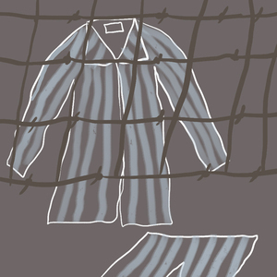
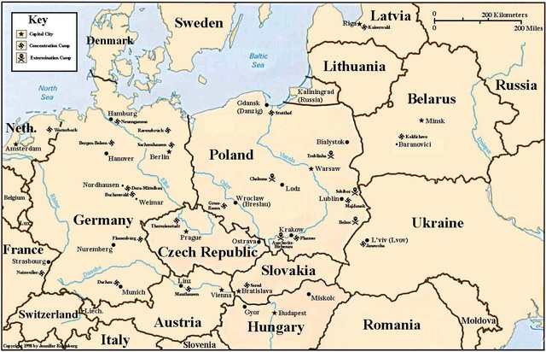
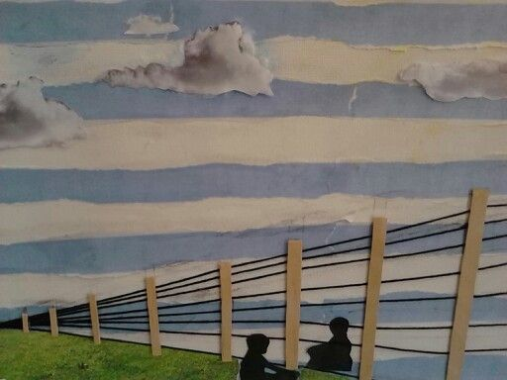
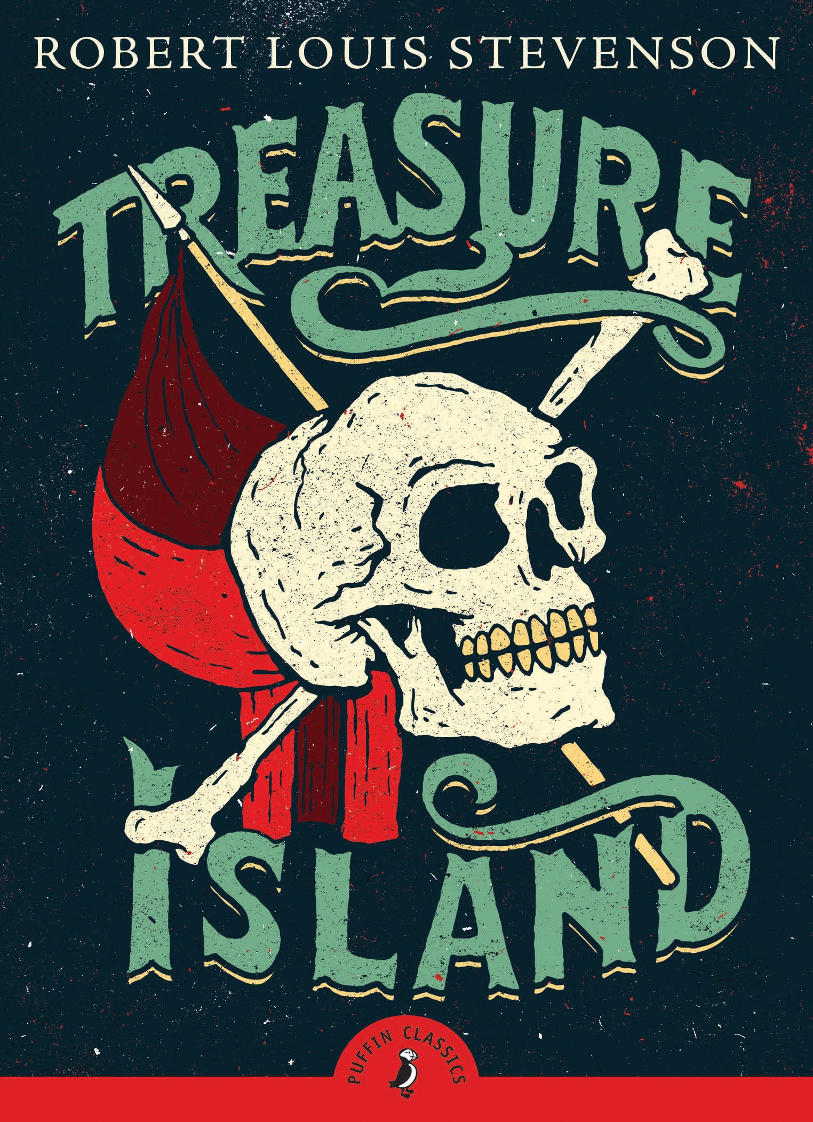

Music

Music:
After reading a novel, figure out how you would divide up the book into sections. Then select a piece of music that you think captures the feel or tone of each section. Record the pieces and if possible do voice-overs explaining what is happening in the novel during the piece of music and why you felt this piece of music fit the section of the novel.

https://www.youtube.com/watch?v=YQ7z_eANAP4
This piece reminds us of the tragedies of the world wars. The lyrics are from a Canadian point of view, however this is something that Bruno would have noticed had he lived (as Canadians were part of the fight in WWII and helped free those in Concentration Camps).

https://www.youtube.com/watch?v=6CJ96LGGP6w
This song is called Forbidden Friendship. It is key to the book as Bruno knows in his heart that he should not be friends with Shmuel, because he is a Jew and Bruno is not. Yet, they are best friends anyway. This song is light and fluffy and screams adventurous – as Bruno very much is. Bruno knows this relationship with Shmuel is not allowed, as he lies directly in front of Lt. Kotler when he asked him if he knew who Shmuel was.
ETC.

Tangible or intangible gifts
Select a character and figure out what six things you believe your character most needs or wants. Draw or cut out pictures to represent these “gifts” and write to your character an explanation of why you picked these things out for him or her.

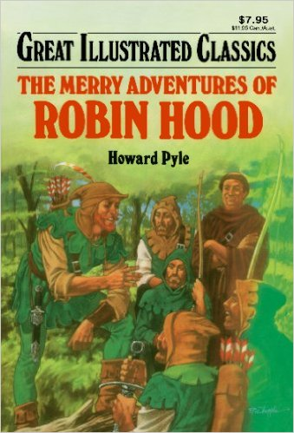
Book: The Merry Adventures of Robin Hood
Bruno liked reading Treasure Island in his spare time. So, as a gift, I would give Bruno the book of Robin Hood. The reason why is because Bruno is adventurous like the main character of this book. It is also the same reading style as Treasure Island and the same heroic story line.
Gift of Love and Understanding:
Bruno’s parents seem to forget that he is a child who needs love and attention. When they moved to Out-With, they knew it was not a child friendly place. Knowing this, they did not give Gretel or Bruno any alternatives to play safety, etc. If his Mother and Father paid more loving attention to Bruno, they would have known he was sneaking off the property.
ETC.

Create a character’s room
We learn a lot about people by what they keep in their closets, what they have on their walls, what they select to put in a room. Select a character you know well and create a living room, bedroom, kitchen, or some other room that would mean a lot to the character. Draw it or write about it, making sure to include an explanation of why you designed the room as you did.

Gretel’s Room:
Dolls – On one wall there would be dolls neatly placed on a shelf. Showing how Gretel found comfort at Out-With (at first) with her dolls as she had no friends/children her own age.
Maps – On another wall there would be maps with pins in it. Showing how Gretel loved to read the newspaper and discover what places they were talking about.
Heart drawing with Kotler’s picture in it – Gretel loved Lt. Kotler. She often flirted with him (tossing her hair) and saying how young her brother Bruno was and how she was almost a teen like him.
Plain colored walls – Gretel’s room would be plain, as when they moved to Out-With the children found the house dirty and not extravagant.
Small Room – It would be small for Gretel as she used to live in a five-story house and now lives in a three-story house.

