1. The perimeter of a square is 24cm. Then the sides of the square are _________cm.

2. The area of a square is 81 cm. Its sides are _________cm.

What is the perimeter of this shape? _______________cm.

3. The name given to the figure below is ______________________________________ .

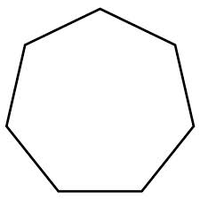

4. Draw an image to prove that an angle is formed by two rays with a common endpoint.

5. Convert the following measurements:

1. 0.45m = ____________cm
2. 0.65m = ____________ mm

6. A rectangle with a base of 3 cm has the same are as the parallelogram below. What is the height of the rectangle?

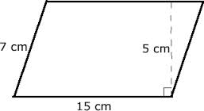

7. Calculate the **perimeter and area** of:

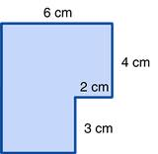

8. Calculate the perimeter of:

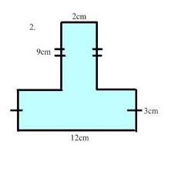

9. Calculate the Area:

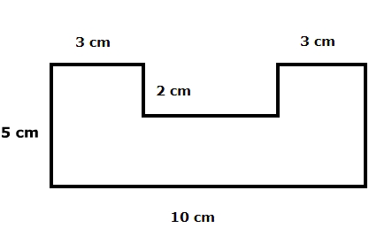

10. Calculate the area of:

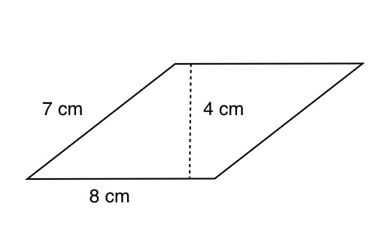

11. Calculate the area:

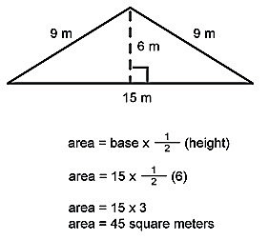

12. Calculate the area:

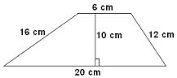

13. Calculate the area of  DEC: (measurement in cm)

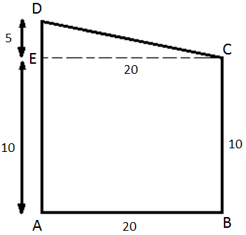

14. Calculate the area of the shaded region in the square below:

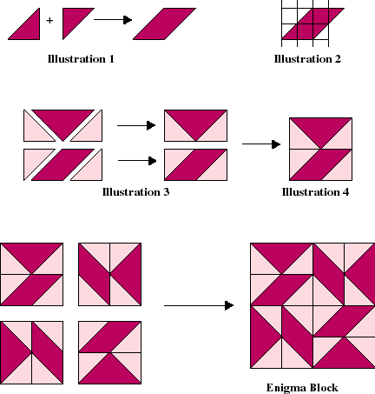



6cm

15. The perimeter of a square is 36 cm. What is the area of the square?