NAME: ______________________ Reproduction
TOTAL: _______ /68

PART A Multiple Choice: 2 points each ( / 20)

- Which of the following statements is true:
  - In general, boys enter puberty before girls
  - The last set of chromosomes code for a male (xx) or a female (xy)
  - The birth control pill works by preventing the ovary from releasing an egg
  - Gametes contain one set of chromosomes.

- Which of the following is a gamete cell?
  - A blood cell
  - A sperm cell
  - A tissue cell
  - A bone cell

- The only method of contraceptive, which protects you from most STI’s is:
  - Oral contraceptives (Birth Control Pills)
  - Condoms
  - The patch
  - Injectable contraception

- What is the hormone responsible for the major changes in puberty in boys
  - Testosterone
  - Progesterone
  - Estrogen
  - Ovulation

- During ovulation the female egg travels from the ovary into the
  - Uterus
  - Cervix
  - Fallopian Tube
  - Fetus

- There are ____ chromosomes in a new cell
  - 10
  - 23
  - 46
  - 21

- The ______ is the part of the plant male reproductive organ where pollen is produced and stored.
  - Stigma
  - Style
  - Anther
  - Ovary
- HIV can be spread…
  - through the use of a pre-used needle
  - through contact with blood of an infected person
  - through sexual intercourse with an infected person
  - All of the above

- The process of cellular respiration occurs in the
  - Nucleus
  - Chloroplast
  - Mitochondrion
  - Cytoplasm

- The process of photosynthesis occurs in the
  - Nucleus
  - Chloroplast
  - Mitochondrion
  - Cytoplasm

PART B: Fill in the Blank (2 point each /14)

WORD BANK:
Embryo Fetus Birth
Fertilization Ovum Zygote Spermatozoon

Steps in Human Reproduction:
- The male gamete (__________________________) fuses with a female gamete

(______________________). This process is called ____________________________________.

- This fusion produces an initial cell called a ___________ that contains complete genetic material.

- Between week 1 to 9 cell division occurs and the developing young is referred to as

________________________.

- After this point the offspring is then referred to as a ______________________.

- _________________ happens after full gestation occurs. For humans, this could occur between week 38 and 40.

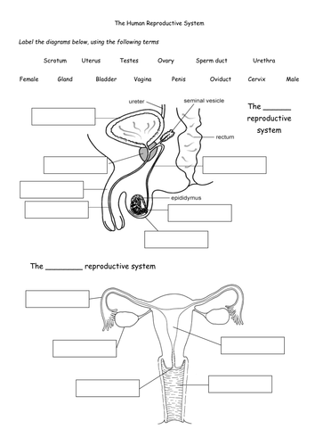
PART C: Label the diagrams ( 1 point each /14)

PART D: Fill in the chart (1 point each /10)

 | Inputs | Outputs
Photosynthesis | 1._______________________  2. ______________________  3. ______________________ | 1. ______________________  2. ______________________
Cellular respiration | 1._______________________  2. ______________________ | 1._______________________  2. ______________________  3. ______________________

PART E: EXPANDED ANSWER /10 points

Using the apple tree as an example, explain the sexual reproduction of this angiosperm (from flowering to new plant growth.)

