Statistics
Ex: 87, 56, 34, 86, 12, 54

Range: Subtract the greatest value from the smallest value.
Ex: 87 – 12 = 75

Mean: Average (Add all values and divide by amount of values in list)
Ex: Step 1: 87 + 56 + 34 + 86 + 12 + 54 = 329
Step 2: 329 ÷ 6 = 54.8 (rounded 55%)

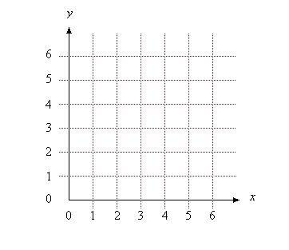

Favorite Animals | Number of Students
Cat | 5
Dog | 2
Horse | 6
Bird | 1

Miles | Rate (Miles/Hour)
0 | 0
1 | 125
2 | 200
3 | 150

Circle Graph:
Expense | Fraction | Percent | Decimal | Degrees
Tuition | 1/4 | 25% | .25 | 90
Room and Board | 1/20 | 5% | 0.05 | 18
Books | 2/5 | 40% | 0.40 | 144
Transportation | 3/10 | 30% | 0.30 | 108
TOTAL | 1 | 100% | 1 | 360
Note: Degrees = Decimal x 360

